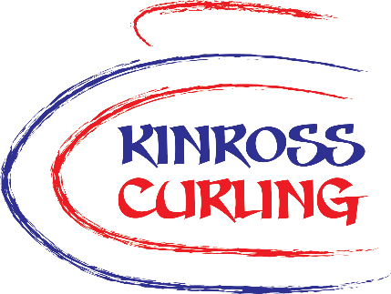
KCT
Membership Form

REQUIRED MEMBER DETAILS
Title |  | First Name |  | Last Name
Address line 1 |  |  |  | Mobile
Address line 2 |  |  |  | Home Phone
Town |  |  |  | Email
Postcode
I wish to apply for membership of Kinross Curling Trust. By signing¹ below, I confirm that I have read and agree to comply with the Trust’s Memorandum and Articles of Association².
I understand membership includes the right to vote in all general meetings of the Trust.
- If completing this form electronically, simply type your name into the signature box.
- These are available on our website on the About the Board page under About us.
Signature |  |  |  | Date
OPTIONAL MEMBER DETAILS
The following information is not required to gain membership, but would be helpful to the Trust:
I am a member of |  |  |  |  | Curling Club(s)
All members will receive necessary emails about membership and general meetings.
If you would also like to receive our newsletter and updates about the rink and events you need to indicate this by marking the box below. You can unsubscribe from news emails at any time.
I would like to receive newsletters and information emails |  |  |  | ☐
Please return completed forms by email to office@kinroscurling.co.uk
or hand in paper copies to the ice office marked FAO Office Manager

